**Subhan Bin Yousaf**

**Section B**

**481281**

**FOP Lab Manual 9**

**Lab Tasks**

**Task 1**

#include <iostream>

using namespace std;

int main(){

int a[3][3], sumleft=0, sumright=0;

cout<<"Input 9 integers in the 3x3 matrix: \n";

for(int i=0; i<3; i++){

for(int j=0; j<3; j++){

cin>>a[i][j];

}

}

cout<<"The values in the matrix are: \n";

for(int i=0; i<3; i++){

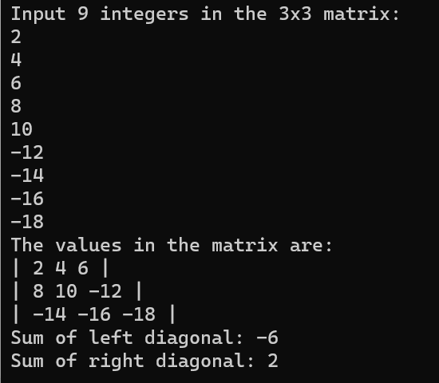 cout<<"| ";

for(int j=0; j<3; j++){

cout<<a[i][j]<<" ";

}

cout<<"|"<<endl;

}

int j=2;

for(int i=0; i<3; i++){

sumleft+=a[i][i];

sumright+=a[j][i];

j--;

}

cout<<"Sum of left diagonal: "<<sumleft<<endl

<<"Sum of right diagonal: "<<sumright<<endl;

return 0;

}

**Task 2**

#include <iostream>

using namespace std;

int main(){

int a[3][3], b[3][3], sum[3][3];

cout<<"Input 9 integers in the 3x3 matrix: \n";

for(int i=0; i<3; i++){

for(int j=0; j<3; j++){

cin>>a[i][j];

}

}

cout<<"Input 9 integers in the second 3x3 matrix: \n";

for(int i=0; i<3; i++){

for(int j=0; j<3; j++){

cin>>b[i][j];

}

}

cout<<"The values in the matrix are: \n";

for(int i=0; i<3; i++){

cout<<"| ";

for(int j=0; j<3; j++){

cout<<a[i][j]<<" ";

}

cout<<"|\t| ";

for(int k=0; k<3; k++){

cout<<b[i][k]<<" ";

}

cout<<"|"<<endl;

}

for(int i=0; i<3; i++){

for(int j=0; j<3; j++){

sum[i][j]=a[i][j]+b[i][j];

}

}

cout<<"The sum of the two matrix is: \n";

for(int i=0; i<3; i++){

cout<<"| ";

for(int j=0; j<3;j++){

cout<<sum[i][j]<<" ";

}

cout<<"|"<<endl;

}

return 0;

}

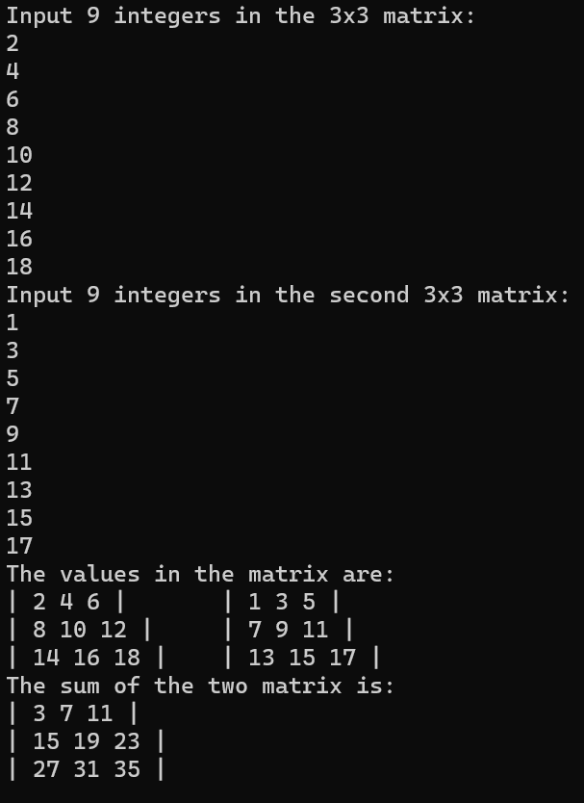

**Task 3**

#include <iostream>

using namespace std;

int transpose(int a[3][3]){

int temp=0;

for(int i=0; i<3; i++){

for(int j=i+1; j<3; j++){

temp=a[i][j];

a[i][j]=a[j][i];

a[j][i]=temp;

}

}

}

int main(){

int a[3][3];

cout<<"Input 9 integers in the 3x3 matrix: \n";

for(int i=0; i<3; i++){

for(int j=0; j<3; j++){

cin>>a[i][j];

}

}

cout<<"The values in the matrix are: \n";

for(int i=0; i<3; i++){

cout<<"| ";

for(int j=0; j<3; j++){

cout<<a[i][j]<<" ";

}

cout<<"|"<<endl;

}

cout<<"The transpose of the matrix is: \n";

transpose(a);

for(int i=0; i<3; i++){

cout<<"| ";

for(int j=0; j<3; j++){

cout<<a[i][j]<<" ";

}

cout<<"|"<<endl;

}

}

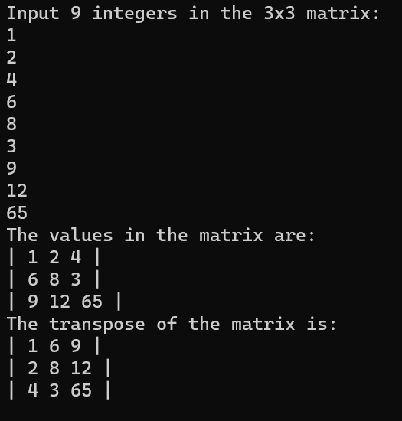

**Task 4**

#include <iostream>

using namespace std;

int multiply(int a[3][3], int b[3][3], int ans[3][3]){

for(int i=0; i<3; i++){

for(int j=0; j<3; j++){

for(int k=0; k<3; k++){

ans[i][j]+=a[i][k]*b[k][j];

}

}

}

}

int main(){

int a[3][3], b[3][3], ans[3][3]={{0},{0}};

cout<<"Input 9 integers in the 3x3 matrix: \n";

for(int i=0; i<3; i++){

for(int j=0; j<3; j++){

cin>>a[i][j];

}

}

cout<<"Input 9 integers in the second 3x3 matrix: \n";

for(int i=0; i<3; i++){

for(int j=0; j<3; j++){

cin>>b[i][j];

}

}

cout<<"The values in the matrix are: \n";

for(int i=0; i<3; i++){

cout<<"| ";

for(int j=0; j<3; j++){

cout<<a[i][j]<<" ";

}

cout<<"|\t| ";

for(int k=0; k<3; k++){

cout<<b[i][k]<<" ";

}

cout<<"|"<<endl;

}

multiply(a, b, ans);

cout<<"The product of the two matrix is: \n";

for(int i=0; i<3; i++){

cout<<"| ";

for(int j=0; j<3; j++){

cout<<ans[i][j]<<" ";

}

cout<<"|"<<endl;

}

return 0;

}

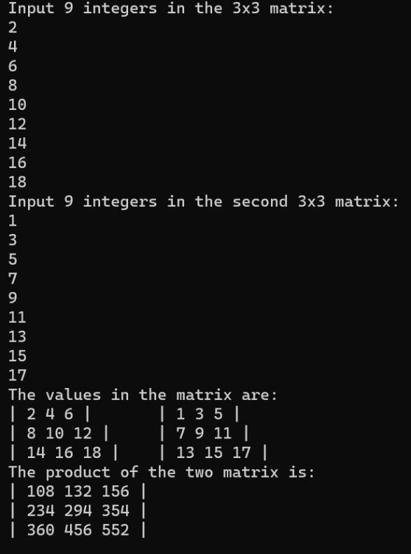

**Task 5**

#include <iostream>

using namespace std;

int table(int a, int temp=1){

if(temp==11){

return 0;

}

cout<<temp<<"*"<<a<<"="<<temp*a<<endl;

return table(a, temp+1);

}

int main(){

int a=15 , product;

cout<<"The table of "<<a<<" is: \n";

table(a);

return 0;

}

